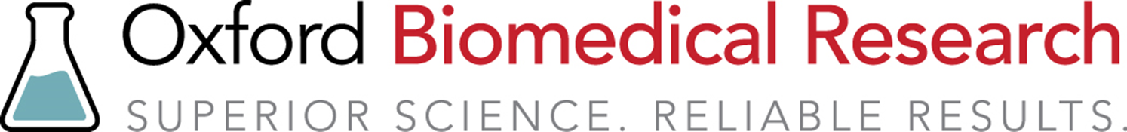

CypExpress Protocol

Procedural Notes
- A starting substrate concentration of 500 µM should be used. The concentration that produces the highest level of metabolite varies for each compound and can be optimized using the Pilot Procedure.
- Many drugs are poorly soluble in water and can be difficult to dissolve in buffer. This can be remedied by preparing a concentrated solution of the compound in dimethylsulfoxide or N,N-dimethylformamide and adding it to the CypExpress/buffer suspension.
- Alcohols should never be used in any CypExpress reactions.
- A 20 mg/mL suspension concentration of CypExpress in buffer is recommended.

Materials
- Allow all reagents to warm to room temperature before starting -

- CypExpress powder
- 100 mM, pH 7.4 potassium phosphate buffer containing 5.0 mM glucose-6-phosphate (G6P) and 2.0 mM nicotinamide adenine dinucleotide phosphate, sodium salt (NADP⁺)
- Concentrated substrate solution in dimethylsulfoxide

Procedure for a Two Milliliter Reaction

- Place 40 mg of CypExpress powder into a test tube with a stir bar. A 16 mm by 125 mm tube works well for this.
- Add 2.0 mL of buffer containing G6P and NADP⁺ to the powder and begin stirring to make a suspension.
- Add the concentrated substrate stock to achieve a 500 µM concentration. For example, adding 2.0 µL of a concentrated 0.5 M testosterone DMSO stock solution to 2.0 mL of buffer gives a final concentration of 500 µM testosterone.
- Stir the uncovered tube at 37°C fast enough to create a vortex.
- Allow the reaction to proceed for four hours.
- Centrifuge the sample at 6,000g for 10 minutes at room temperature.
- Remove the supernatant and re-suspend the pellet in 1.0 mL of acetone.
- Centrifuge, remove the supernatant and combine it with the first supernatant sample.
- Remove the water and acetone to give the metabolites and starting material for separation and analysis.

If you have any questions, please contact us:
Toll free: 800.692.4633
Fax: 248.852.4466
email: info@oxfordbiomed.com
www.oxfordbiomed.com

Warranty and Limitation of Remedy

Oxford Biomedical Research, Inc. (OBR) makes no warranty or guarantee of any kind, whether written, oral, expressed or implied that includes without limitation, any warranty of fitness for a particular purpose, suitability and merchantability which extends beyond the description of the reagents/chemicals here. OBR warrants only to the original purchaser that the materials in this kit will meet product specifications at the time of delivery. OBR will complete its delivery obligations with care and handling. Under no circumstances will OBR have any obligation or liability, whether in tort (including negligence) or in contract, for any direct, indirect, consequential or incidental damages, even if OBR is informed about the possibility of their existence. This limitation of liability does not apply in the case of intentional acts or negligence of OBR or its employees.

The Buyer’s exclusive remedy and OBR’s sole liability shall be limited to a refund of the purchase price of the kit, or at the discretion of OBR, the replacement of the kit at no cost to the buyer, of all material that fails to meet our specifications. Said refund or replacement is conditional on the Buyer giving written notice to OBR within thirty (30) days of receipt of the material. Failure of Purchaser to give said notice within thirty (30) days shall constitute a waiver by Purchaser of all claims hereunder with respect to said material.

